Build a Natural Language SQL Agent

Overview
In the modern business landscape, organizations face an ongoing challenge of extracting meaningful insights from vast SQL databases. The conventional approach involves crafting complex SQL queries, manipulating data, and building visualization tools---tasks that demand considerable time and specialized technical knowledge.
The emergence of AI and natural language processing technologies has transformed how we interact with databases. Instead of mastering complex SQL syntax, users can now simply ask questions in everyday language such as Show me last year's revenue patterns or Which items are most frequently returned? and get instant, visualized answers. This project will guide you through setting up an AI-powered system that converts natural language into MySQL database queries, making data analysis accessible to everyone on your team.

Objective
In this project, you will:
- Integrate natural language processing: Use AI tools to interpret natural language queries.
- Execute SQL queries from natural language: Translate natural language questions into SQL queries to fetch relevant data from the MySQL database.

Set up a virtual environment
Begin by creating a virtual environment. Using a virtual environment lets you manage dependencies for different projects separately, avoiding conflicts between package versions.
In your Cloud IDE terminal, ensure that you are in the path /home/project, then run the following commands to create a Python virtual environment.
bash
pip install virtualenv
virtualenv my_env # create a virtual environment named my_env
source my_env/bin/activate # activate my_env

Run
You will see the (my_env) prefix in your terminal. This prefix indicates that the virtual environment is active.

Install necessary libraries
To ensure a seamless execution of the scripts, and considering that certain functions within these scripts rely on external libraries, it's essential that you install some prerequisite libraries before you begin.
- ibm-watsonx-ai and ibm-watson-machine-learning: The IBM Watson Machine Learning package integrates powerful IBM LLM models into the project.
- langchain, langchain-ibm, and langchain-community: This library is used for relevant features from LangChain.
- mysql-connector-python: This library is used as a MySQL database connector.
Run the following commands in your terminal (with the my_env prefix) to install the packages.
bash
python3.11 -m pip install ibm-watsonx-ai==1.0.4 \
ibm-watson-machine-learning==1.0.357 \
langchain==0.2.1 \
langchain-ibm==0.1.7 \
langchain-experimental==0.0.59 \
mysql-connector-python==8.4.0

Instantiate a MySQL database
Because this lab focuses on querying a MySQL database using natural language, you must instantiate a MySQL server, and then create a sample database in the server.

Create a MySQL server
To create a MySQL server in Cloud IDE, click the following button.
Open and Start MySQL in IDE
After you click the button, you'll see a MySQL service on the right. Click Create to start the MySQL server.
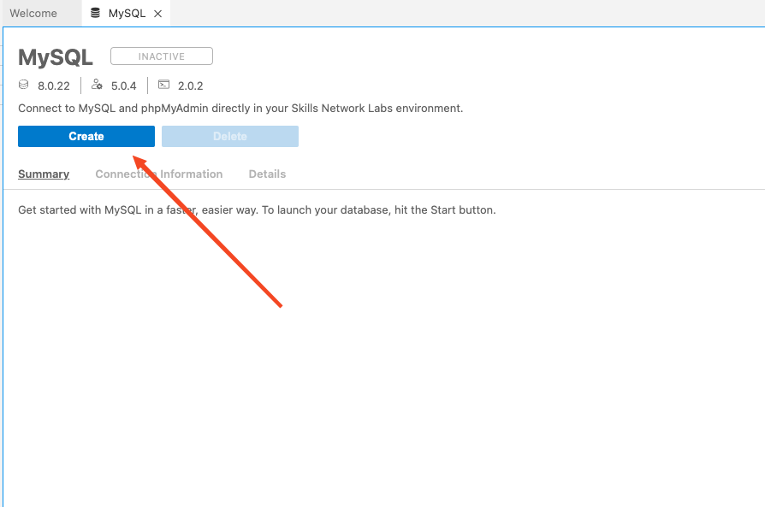
It might take approximately 10-15 seconds to start. When it's showing active, the server is ready to be used. If you see any error messages, refresh the page and try again.
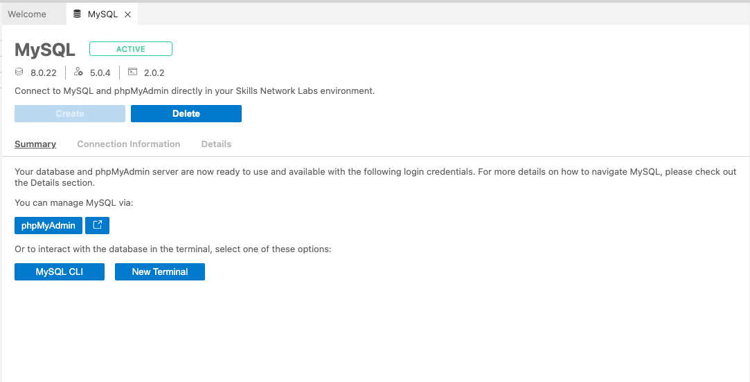
You have now created a MySQL server. Let's test it to see if it will run successfully.
Click MySQL CLI so that you can interact with the server in the terminal. A new terminal tab opens showing something similar to the following image with the mysql prefix at the start.
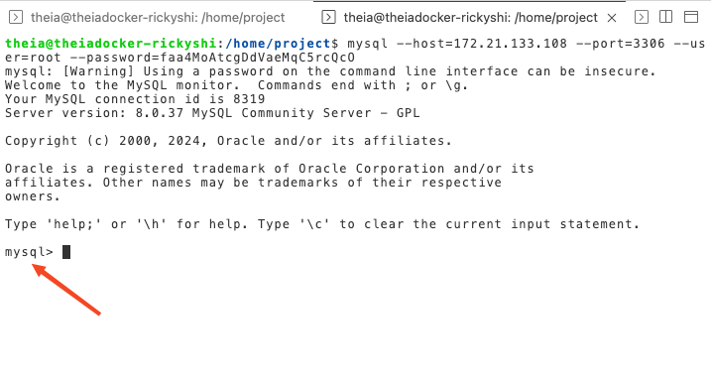
This means that you have successfully connected with the server. Now, let's input an SQL query to test it. For example, the following command shows all databases in the server.
sql
SHOW DATABASES;

Please copy and paste the above command into the terminal with the mysql prefix, and press enter/return on your keyboard. If it runs successfully, it returns an output similar to the following image.
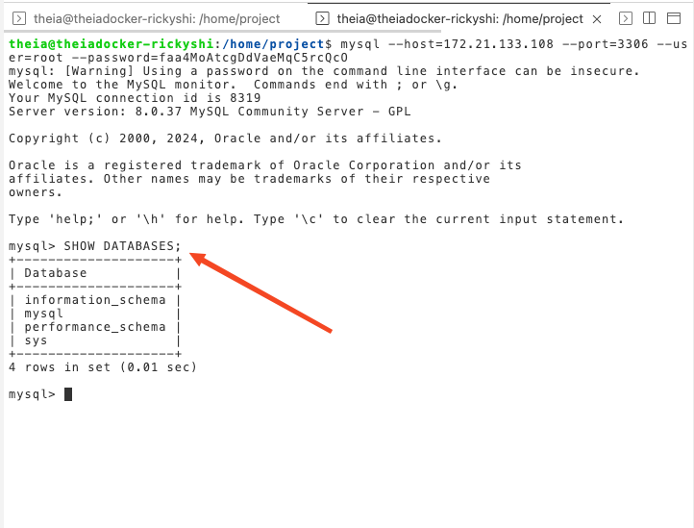
Congratulations, the server is working correctly. Now, let's create a sample database to use.

Create the Chinook database
In this lab, you'll use the Chinook database as an example.

Introduction to the Chinook database
The Chinook database models a comprehensive digital media store ecosystem, featuring interconnected tables that track artists, albums, media tracks, invoices, and customer information. Here's what makes it unique:
- The media catalog contains authentic data sourced directly from an Apple iTunes library
- Customer and employee records use carefully crafted fictional data, including Google Maps-verified addresses and properly formatted contact details (phone numbers, fax, email addresses)
- The sales data spans a 4-year period and was generated programmatically with randomized but realistic values
Key characteristics of the database:
- Comprehensive structure with 11 distinct tables
- Robust data integrity through indexes and primary/foreign key relationships
- Rich dataset containing more than 15,000 records
Below you'll find the entity relationship diagram (ERD) that illustrates how the different components of the Chinook database connect and interact with each other.
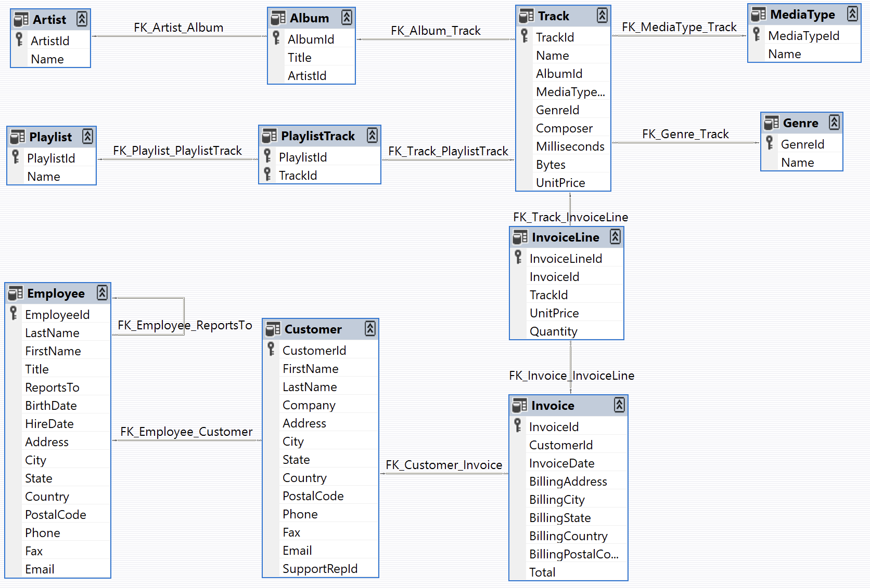

Retrieve the database creation code
The database creation code has been prepared for you.
Before you run the code, please ensure that you are in the path /home/project in the terminal with the (my_env) prefix.
Run the following code in the terminal to retrieve the SQL file from the remote.
Note: Run the code in the terminal with the (my_env) prefix instead of the mysql prefix.
bash
wget https://cf-courses-data.s3.us.cloud-object-storage.appdomain.cloud/Mauh_UvY4eK2SkcHj_b8Tw/chinook-mysql.sql

Run
After it runs successfully, you'll see an SQL file in PROJECT.
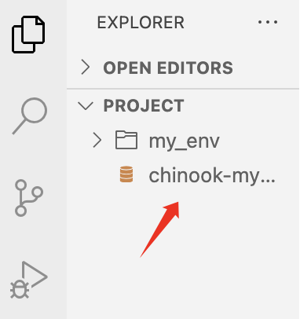

Run the SQL file
Now, you must execute the SQL file to create the database.
Note: Run the code in the terminal with the mysql prefix instead of the (my_env) prefix.
At the terminal with the mysql prefix, copy and paste the following command.
sql
SOURCE chinook-mysql.sql;

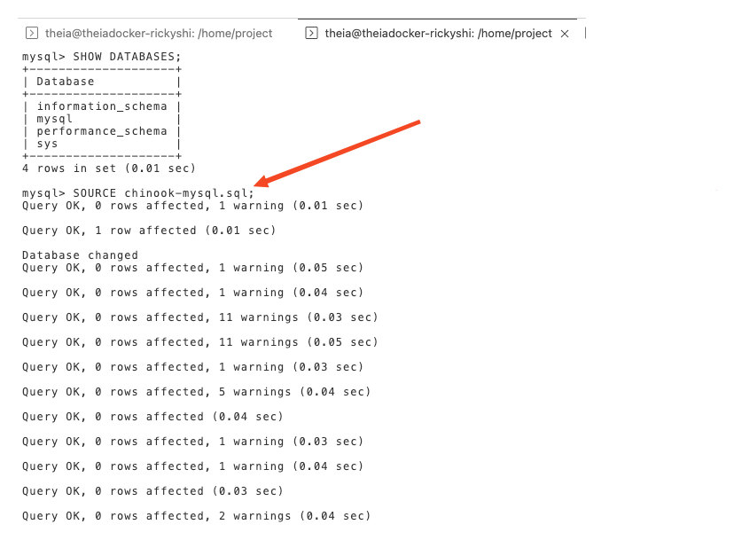
After it runs successfully, you'll see the Chinook database in your list of databases.
To check this, you can run the following command.
sql
SHOW DATABASES;

If the database was successfully created, you'll see the Chinook database in your list of databases.
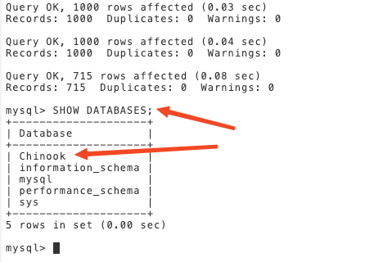
Congratulations, the database was created successfully.
Now let's run some sample SQL commands to interact with the Chinook database. For example, suppose you want to know how many albums the Chinook database contains. To find this information, you could run the following SQL command.
sql
USE Chinook;
SELECT COUNT(*) FROM Album;

When you copy and paste the previous command into the terminal with the mysql prefix, you should get an answer of 347.
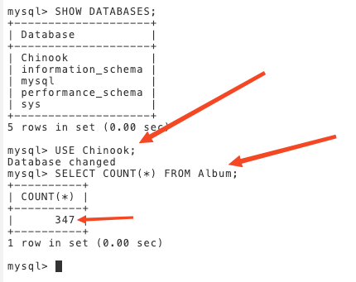

Instantiate an LLM
This section guides you through the process of instantiating an LLM by using the watsonx.ai API. This section uses the ibm/granite-4-h-small model. To find other foundational models that are available on watsonx.ai, refer to Foundation model library.

Create the LLM
Click the following button to create an empty Python file that is named llm_agent.py.
Open llm_agent.py in IDE
If file llm_agent.py does not create automatically, you can manually create it in this project.
The following code creates an LLM object by using the watsonx.ai API. Copy and paste it to the llm_agent.py file, then go to File > Save.
python
# Use this section to suppress warnings generated by your code:
def warn(*args, **kwargs):
pass
import warnings
warnings.warn = warn
warnings.filterwarnings('ignore')

from ibm_watsonx_ai.foundation_models import ModelInference
from ibm_watsonx_ai.metanames import GenTextParamsMetaNames as GenParams
from ibm_watsonx_ai.foundation_models.utils.enums import ModelTypes
from ibm_watson_machine_learning.foundation_models.extensions.langchain import WatsonxLLM
from langchain_community.utilities.sql_database import SQLDatabase
from langchain_community.agent_toolkits import create_sql_agent

model_id = 'ibm/granite-4-h-small'

parameters = {
GenParams.MAX_NEW_TOKENS: 256, # This controls the maximum number of tokens in the generated output
GenParams.TEMPERATURE: 0.5, # This randomness or creativity of the model's responses
}

credentials = {
"url": "https://us-south.ml.cloud.ibm.com"
}

project_id = "skills-network"

model = ModelInference(
model_id=model_id,
params=parameters,
credentials=credentials,
project_id=project_id
)

granite_llm = WatsonxLLM(model = model)

print(granite_llm.invoke("What is the capital of Ontario?"))

Note that in addition to creating the LLM object, the previous code includes the sample query 'What is the capital of Ontario?'. This query was included to test whether the model is being correctly loaded by the script.

Test the model
Run the following command in the terminal with the my_env prefix.
bash
python3 llm_agent.py

Run
If you were successful, you'll see a response in the terminal that's similar to the following response.
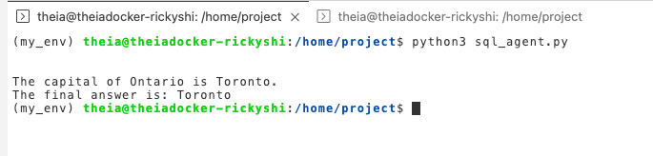
Great, the LLM is ready to be used!

Build the database connector
Click the following button to create an empty Python file that is named sql_agent.py.
Open sql_agent.py in IDE
If file sql_agent.py does not create automatically, you can manually create it in this project.
The whole code will be provided later.
First, please copy and paste all the code in llm_agent.py to the sql_agent.py file.
Building the database connector is simple. It requires just two lines of code:
python
mysql_uri = 'mysql+mysqlconnector://{mysql_username}:{mysql_password}@{mysql_host}:{mysql_port}/{database_name}'
db = SQLDatabase.from_uri(mysql_uri)

You must define
- mysql_username
- mysql_password
- mysql_host
- mysql_port
- database_name.
To find the values of these parameters, go to the MySQL service. Then, click the Connection Information tab. Under this tab, you'll find almost all of the necessary parameter values, except for the database_name, which is the database you created earlier, Chinook.
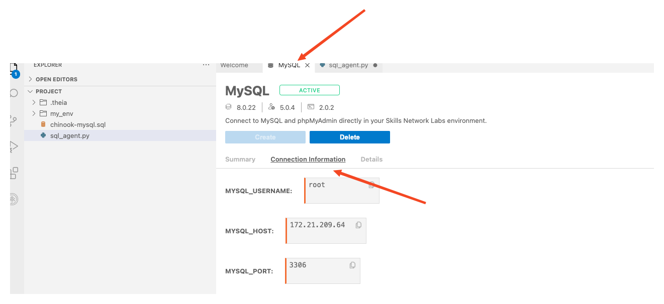
Replace the connection information in the following code with the values that you get from your MySQL server.
python
mysql_username = 'root'
mysql_password = 'zQTLH3HB0q3ahCuAaDcAwdlb' # Replace with your server connect information
mysql_host = '172.21.52.20' # Replace with your server connect information
mysql_port = '3306' # Replace with your server connect information
database_name = 'Chinook'
mysql_uri = f'mysql+mysqlconnector://{mysql_username}:{mysql_password}@{mysql_host}:{mysql_port}/{database_name}'
db = SQLDatabase.from_uri(mysql_uri)

You should add the above code, to the sql_agent.py file.
Delete the following line from the sql_agent.py file.
python
print(granite_llm.invoke("What is the capital of Ontario?"))

After adding the two lines for the database connector and deleting the print() line, save sql_agent.py.
The following code is the complete code to this point.
python
# Use this section to suppress warnings generated by your code:
def warn(*args, **kwargs):
pass
import warnings
warnings.warn = warn
warnings.filterwarnings('ignore')
from ibm_watsonx_ai.foundation_models import ModelInference
from langchain.agents import AgentType
from ibm_watsonx_ai.metanames import GenTextParamsMetaNames as GenParams
from ibm_watsonx_ai.foundation_models.utils.enums import ModelTypes
from ibm_watson_machine_learning.foundation_models.extensions.langchain import WatsonxLLM
from langchain_community.utilities.sql_database import SQLDatabase
from langchain_community.agent_toolkits import create_sql_agent

model_id = 'ibm/granite-4-h-small'

parameters = {
GenParams.MAX_NEW_TOKENS: 1024, # this controls the maximum number of tokens in the generated output
GenParams.TEMPERATURE: 0.2, # this randomness or creativity of the model's responses
GenParams.TOP_P: 0.95,
GenParams.REPETITION_PENALTY: 1.2,
}
credentials = {
"url": "https://us-south.ml.cloud.ibm.com"
}

project_id = "skills-network"

model = ModelInference(
model_id=model_id,
params=parameters,
credentials=credentials,
project_id=project_id
)

llm = WatsonxLLM(model = model)
mysql_username = 'root' # Replace with your server connect information
mysql_password = 'TGbWkWxf2iPljYE3mYm8ilBj' # Replace with your server connect information
mysql_host = '172.21.155.85' # Replace with your server connect information
mysql_port = '3306' # Replace with your server connect information
database_name = 'Chinook'
mysql_uri = f'mysql+mysqlconnector://{mysql_username}:{mysql_password}@{mysql_host}:{mysql_port}/{database_name}'
db = SQLDatabase.from_uri(mysql_uri)

You'll use the `create_sql_agent` from LangChain to interact with your SQL database. The primary benefits of using this SQL agent include:
- Answering questions based on the database's schema and content, such as describing specific tables.
- Error recovery by executing a generated query, capturing any tracebacks, and regenerating the query if necessary.
- Multiple queries to the database to thoroughly answer user questions.
- Token efficiency by retrieving schemas only from pertinent tables.
agent_executor = create_sql_agent(llm=llm, db=db, verbose=True, handle_parsing_errors=True, agent_type=AgentType.ZERO_SHOT_REACT_DESCRIPTION) is the code to create the SQL agent.
Parameters:
- llm: The LLM object that you created earlier.
- db: The database connector that you created earlier.
- verbose: Whether to print the verbose output.
- handle_parsing_errors: Whether to handle parsing errors.
The following code asks the SQL agent to find the number of albums in the database by using plain English. Append these lines to the sql_agent.py file and save the file.
python
agent_executor.invoke(
"How many Album are there in the database?"
)

The following code is the completed sql_agent.py file. Please note that you would have to modify the mysql_uri = line to point to your MySQL database.
python
# Use this section to suppress warnings generated by your code:
def warn(*args, **kwargs):
pass
import warnings
warnings.warn = warn
warnings.filterwarnings('ignore')
from ibm_watsonx_ai.foundation_models import ModelInference
from langchain.agents import AgentType
from ibm_watsonx_ai.metanames import GenTextParamsMetaNames as GenParams
from ibm_watsonx_ai.foundation_models.utils.enums import ModelTypes
from ibm_watson_machine_learning.foundation_models.extensions.langchain import WatsonxLLM
from langchain_community.utilities.sql_database import SQLDatabase
from langchain_community.agent_toolkits import create_sql_agent

model_id = 'ibm/granite-4-h-small'

parameters = {
GenParams.MAX_NEW_TOKENS: 1024, # this controls the maximum number of tokens in the generated output
GenParams.TEMPERATURE: 0.2, # this randomness or creativity of the model's responses
GenParams.TOP_P: 0.95,
GenParams.REPETITION_PENALTY: 1.2,
}
credentials = {
"url": "https://us-south.ml.cloud.ibm.com"
}

project_id = "skills-network"

model = ModelInference(
model_id=model_id,
params=parameters,
credentials=credentials,
project_id=project_id
)

llm = WatsonxLLM(model = model)
mysql_username = 'root' # Replace with your server connect information
mysql_password = 'TGbWkWxf2iPljYE3mYm8ilBj' # Replace with your server connect information
mysql_host = '172.21.155.85' # Replace with your server connect information
mysql_port = '3306' # Replace with your server connect information
database_name = 'Chinook'
mysql_uri = f'mysql+mysqlconnector://{mysql_username}:{mysql_password}@{mysql_host}:{mysql_port}/{database_name}'
db = SQLDatabase.from_uri(mysql_uri)

agent_executor = create_sql_agent(llm=llm, db=db, verbose=True, handle_parsing_errors=True, agent_type=AgentType.ZERO_SHOT_REACT_DESCRIPTION)

agent_executor.invoke(
"How many Album are there in the database?"
)

Please copy and paste the previous code to the sql_agent.py file. Then, save the file and go to the terminal with the my_env prefix, and run the following command.
bash
python3 sql_agent.py

Run
If the agent runs successfully, you'll see a response similar to the following:
The Natural Language Query (NLQ) is:
plaintext
How many Album are there in the database?

The response is:
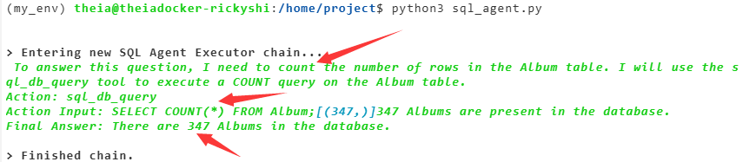
By setting verbose=True in the code, you get to see not just the Final Answer, but also the complete thought process - including all actions taken by the LLM and the actual SQL queries it generates to arrive at that answer. When running correctly, the agent will confirm there are 347 albums in the database, matching exactly what a direct SQL query would return.
NOTE: If you encounter any errors, please use ctrl + C in the terminal and run the code again.

Examples and Exercises
Please change the query in the sql_agent.py file to the following query and run it.
For example,
Change the query from:
python
agent_executor.invoke(
"How many Album are there in the database?"
)

to:
python
agent_executor.invoke(
"Describe the PlaylistTrack table"
)

Natural Language Query (NLQ):
plaintext
Describe the PlaylistTrack table

Response:
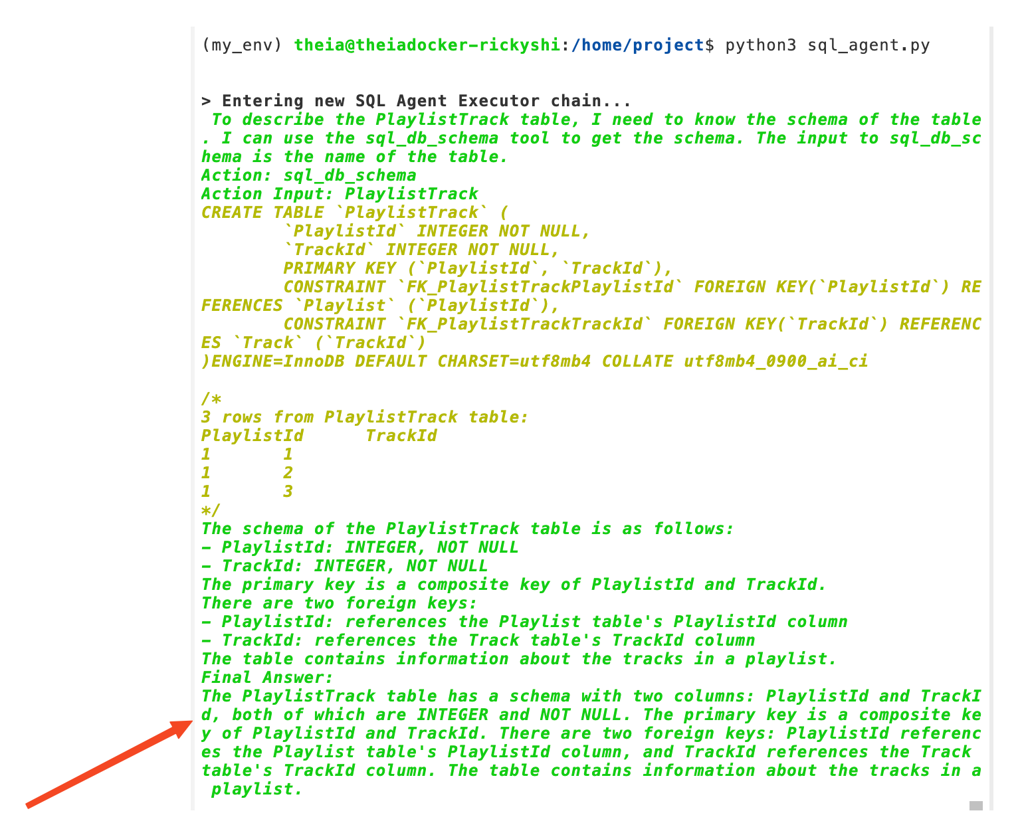
Natural Language Query (NLQ):
plaintext
How many employees are there

Response:
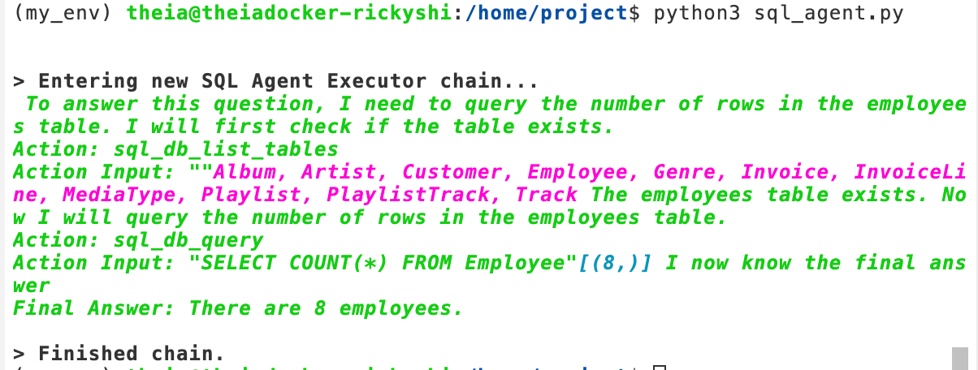
Natural Language Query (NLQ):
plaintext
Can you left join table Artist and table Album by ArtistId? Please show me 5 Name and AlbumId in the joint table.

Response:
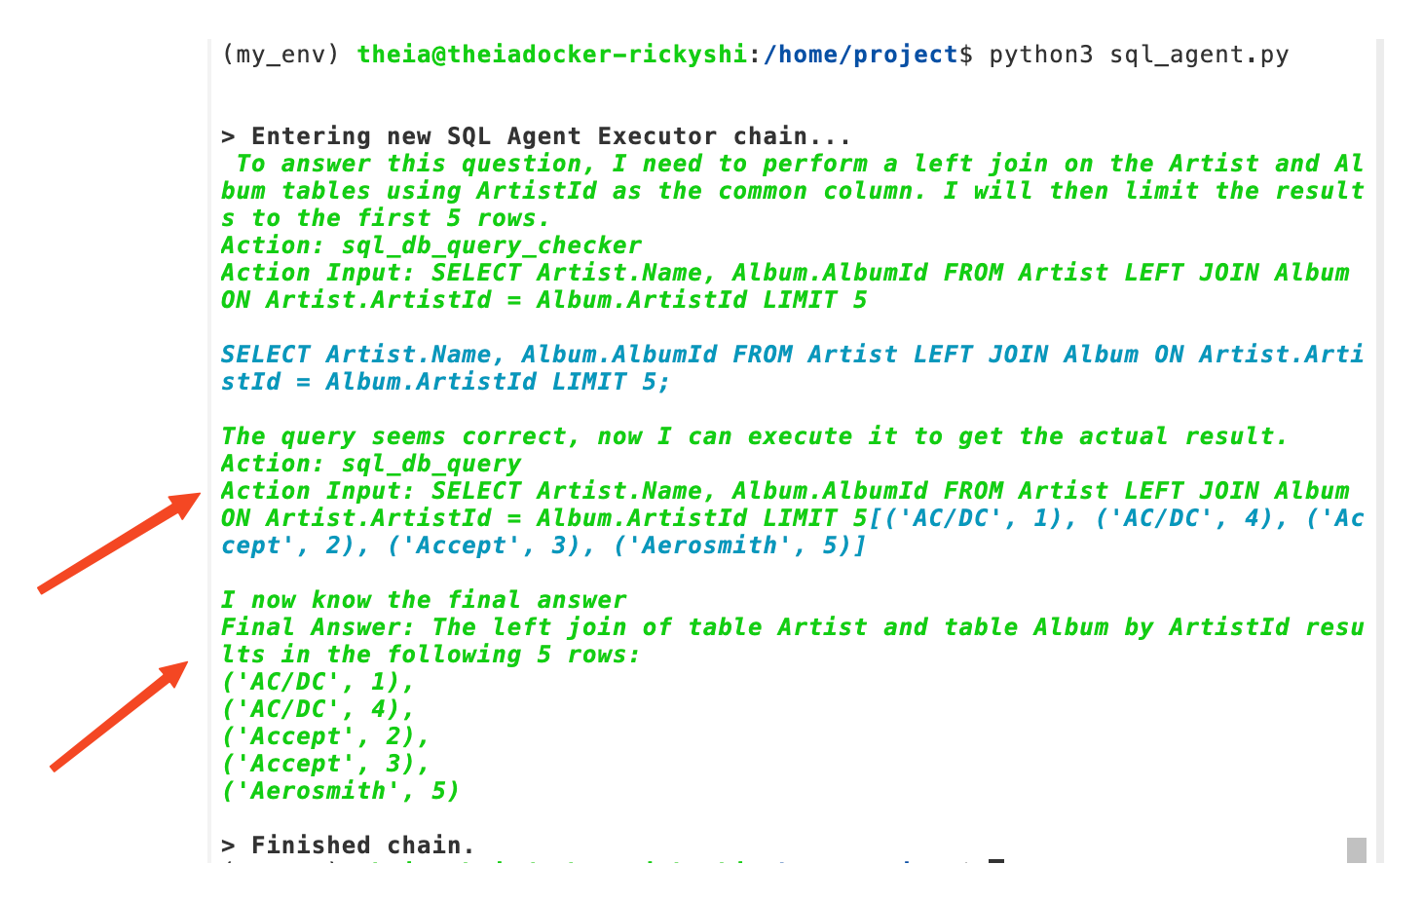
Natural Language Query (NLQ):
plaintext
Which country's customers spent the most by invoice?

Response:
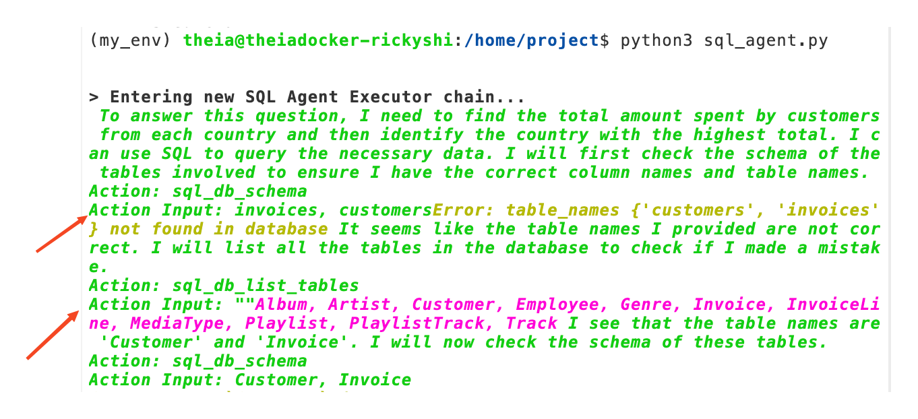
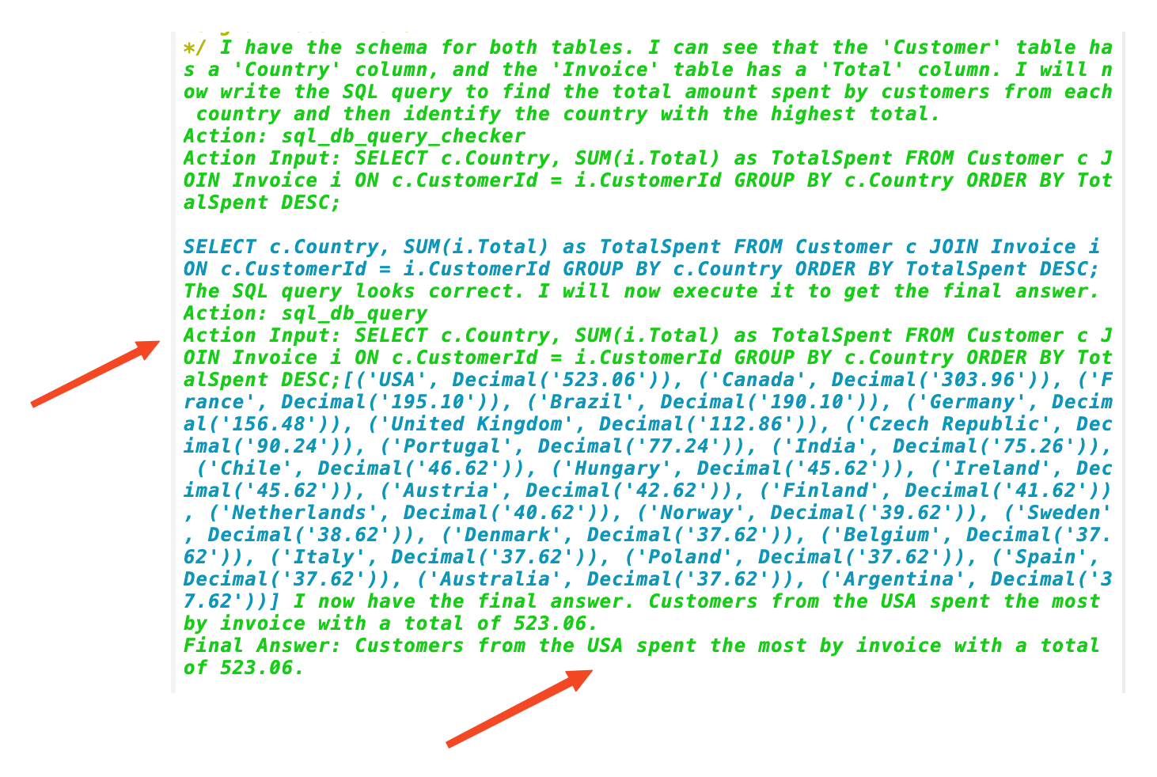

Use the command line to run Natural Language Query (NLQ)
Copy and paste the following code to the sql_agent.py file.
NOTE: remember to replace the mysql_username, mysql_password, mysql_host, mysql_port, and database_name with your own values.
python
def warn(*args, **kwargs):
pass
import warnings
warnings.warn = warn
warnings.filterwarnings('ignore')
from ibm_watsonx_ai.foundation_models import ModelInference
from langchain.agents import AgentType
from ibm_watsonx_ai.metanames import GenTextParamsMetaNames as GenParams
from ibm_watsonx_ai.foundation_models.utils.enums import ModelTypes
from ibm_watson_machine_learning.foundation_models.extensions.langchain import WatsonxLLM
from langchain_community.utilities.sql_database import SQLDatabase
from langchain_community.agent_toolkits import create_sql_agent
import argparse

# Set up argument parser
parser = argparse.ArgumentParser()
parser.add_argument("--prompt", type=str, help="The prompt to send to the SQL agent")
args = parser.parse_args()

model_id = 'ibm/granite-4-h-small'

parameters = {
GenParams.MAX_NEW_TOKENS: 1024, # this controls the maximum number of tokens in the generated output
GenParams.TEMPERATURE: 0.2, # this randomness or creativity of the model's responses
GenParams.TOP_P: 0.95,
GenParams.REPETITION_PENALTY: 1.2,
}
credentials = {
"url": "https://us-south.ml.cloud.ibm.com"
}

project_id = "skills-network"

model = ModelInference(
model_id=model_id,
params=parameters,
credentials=credentials,
project_id=project_id
)

llm = WatsonxLLM(model = model)
mysql_username = 'root' # Replace with your server connect information
mysql_password = 'nVEOA1iQqBOz4cftLGdhXuTu' # Replace with your server connect information
mysql_host = '172.21.47.178' # Replace with your server connect information
mysql_port = '3306' # Replace with your server connect information
database_name = 'Chinook'
mysql_uri = f'mysql+mysqlconnector://{mysql_username}:{mysql_password}@{mysql_host}:{mysql_port}/{database_name}'
db = SQLDatabase.from_uri(mysql_uri)

agent_executor = create_sql_agent(llm=llm, db=db, verbose=True, handle_parsing_errors=True, agent_type=AgentType.ZERO_SHOT_REACT_DESCRIPTION)

# Use the prompt from command line argument
if args.prompt:
agent_executor.invoke(args.prompt)
else:
print("Please provide a prompt using --prompt argument")

To run the code, you can use the following command in the terminal with the my_env prefix.
bash
python3 sql_agent.py --prompt "How many Album are there in the database?"

Run
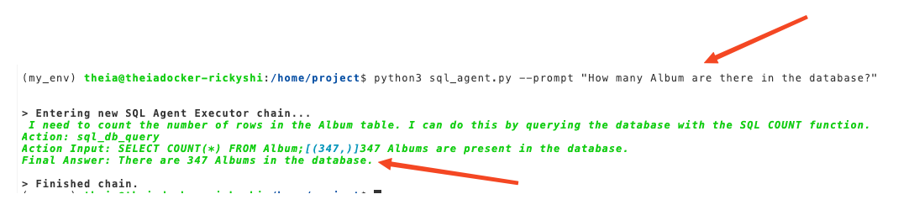
bash
python3 sql_agent.py --prompt "How many employees are there"

Run
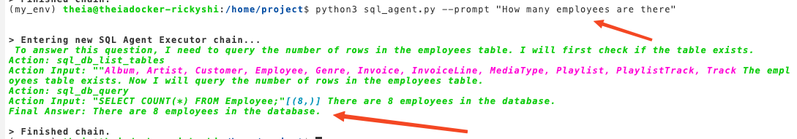
bash
python3 sql_agent.py --prompt "Can you left join table Artist and table Album by ArtistId? Please show me 5 Name and AlbumId in the joint table."

Run
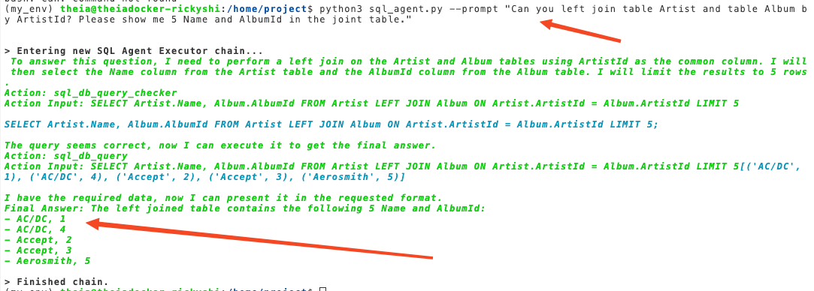
Please try more examples by yourself:
bash
python3 sql_agent.py --prompt "Describe the PlaylistTrack table"

Run
bash
python3 sql_agent.py --prompt "Which country's customers spent the most by invoice?"

Run
Congratulations, you have finished the project!

Author(s)
Ricky Shi Ricky Shi is a Data Scientist at IBM.

Contributors
Karan Goswami Kunal Makwana Wojciech \"Victor\" Fulmyk

